**Implementation of Test Rig:**

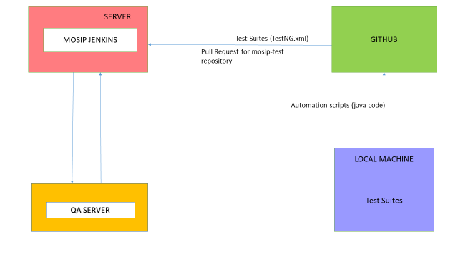

Note: Above diagram will be updated once docker is in place.

**Step1:**

Test Engineers will manually push java code built on (Rest Assured library+TestNG) to github into below folder location:

<https://github.com/mosip/mosip-test/tree/DEV/automation/mosip-qa>

**Step2:**

Java repository is pulled from git into local Mosip Jenkins server (linux machine) where scripts need to be executed.

In this process whole “mosip-test” repository is copied into Mosip Jenkins server and Jenkins workspace is created.

**Note:** This repository is for temporary purpose.Files will be moved to Mosip repository in future.

**Step3:**

Automation project is run as maven build which triggers the TestNG xml to run as a Test Suite.

**Step4:**

After execution, TestNG reports are generated in Target folder of the repository where Test Suite execution status can be viewed.

**Step5:**

I will work on procedure to publish the TestNG execution report on Jenkins dashboard.

**Step6:**

In future Test Automation execution status will also be published on Zephr.